
WEEK-9

- AIM: Write a program to understand the importance of using hooks

DESCRIPTION: This program demonstrates how to use React Hooks such as useState and useEffect to manage state and side effects in functional components. It shows how hooks allow developers to write cleaner, reusable, and more maintainable code without relying on class components. The program helps learners understand state management, lifecycle handling, and the benefits of hooks in building modern React applications.

PROGRAM:

(App.jsx)
import React, { useState, useEffect } from "react"; function HookExample() {
const [count, setCount] = useState(0);

useEffect(() => {
document.title = `Clicked ${count} times`;
}, [count]);

return (
<div>
<p>You clicked {count} times.</p>
<button onClick={() => setCount(count + 1)}>Click</button>
</div>
);
}

export default HookExample;

(Main.jsx)

import { StrictMode } from 'react'
import { createRoot } from 'react-dom/client' import './index.css'
import App from './App.jsx'
createRoot(document.getElementById('root')).render(
<StrictMode>
<App />
</StrictMode>,
)

(Index.html)
<!doctype html>
<html lang="en">
<head>
<meta charset="UTF-8" />

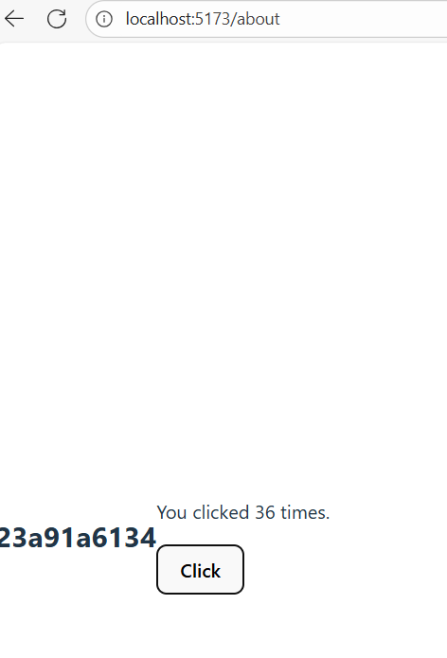
<link rel="icon" type="image/svg+xml" href="/vite.svg" />
<meta name="viewport" content="width=device-width, initial-scale=1.0" />
<title>my-app-week9a</title>
</head>
<body>
<h2>23a91a6134</h2><br>
<div id="root"></div>
<script type="module" src="/src/main.jsx"></script>
</body>
</html>

OUTPUT:

- AIM: Write a program for sharing data between components.

DESCRIPTION: This program demonstrates how to pass and manage data between components in React using props for parent-to-child communication and callback functions or context for child-to-parent or sibling communication. It helps learners understand component hierarchy, data flow, and state management, enabling dynamic and interactive applications where multiple components can access and update shared data efficiently.

PROGRAM:

(App.jsx)

import React, { createContext, useContext } from "react"; const UserContext = createContext();
function Child() {
const user = useContext(UserContext); return <h2>Hello kesava, {user}!</h2>;
}

function Parent() { return (
<UserContext.Provider value="John Doe">
<Child />
</UserContext.Provider>
);
}

export default Parent;

(Main.jsx)
import { StrictMode } from 'react'
import { createRoot } from 'react-dom/client' import './index.css'
import App from './App.jsx'

createRoot(document.getElementById('root')).render(
<StrictMode>
<App />
</StrictMode>,
)

(Index.html)
<!doctype html>

<html lang="en">
<head>
<meta charset="UTF-8" />
<link rel="icon" type="image/svg+xml" href="/vite.svg" />
<meta name="viewport" content="width=device-width, initial-scale=1.0" />

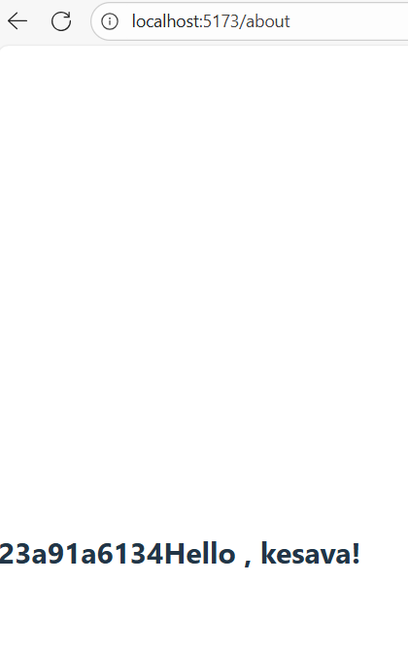
<title>my-app-week9b</title>
</head>
<body>
<h2>23a91a6134</h2>
<div id="root"></div>
<script type="module" src="/src/main.jsx"></script>
</body>
</html>

OUTPUT:

